Title: | AWS Linux Server Installation
Updated: | April 3, 2025 | Due Date: | Midnight before the next class meeting.
Purpose: | The purpose of this lab is to provide you with hands-on experience in configuring a Linux server on Amazon Web Services (AWS), setting up security rules, and performing system updates to ensure a secure and functional environment. This lab enhances your practical understanding of cloud infrastructure and server management in a professional DevOps context.  This lab addresses competency 2 – Perform basic Linux tasks.
Knowledge: | After completing this lab, you will understand how to configure, secure, and update a Linux server instance on AWS while managing cloud-based resources effectively​​.
Task/Activity: | A. Environment Setup (Amazon Web Services - AWS)  B. Linux Server Setup (AWS)  C. Security Group Changes (Firewall)  D. Server Information  E. Reflection
Criteria for Success: | Success in this lab is marked by accurate task completion, effective analysis, documentation, and clear communication of findings. A crucial aspect involves reflecting on the purpose of the lab, linking procedures to broader concepts, and recognizing the lab's significance within the course.  Overall, success is not only measured by technical proficiency but also by critical thinking, effective communication, and a reflective summary that captures the challenges faced and insights gained throughout the lab experience.
- Environment Setup (Amazon Web Services - AWS)
To get the environment setup that we will be using for the rest of the term, we need to install the server that we will be using. In other courses, you may have used a local virtual machine. In this course, we are going to utilize the cloud.
There are a lot of different options to launch a virtual machine in the cloud. Each service has its own pros and cons. In this course, we are going to use the free tier of Amazon Web Services (AWS). There are a few steps to getting the service running.
- Browse to https://awsacademy.instructure.com/login/canvas and login using your Western student email address (lastnamef@students.westerntc.edu). If you have not logged in before, you can select the “Forgot Password?” link to reset your password.
- Once logged into the Dashboard, you should see the AWS Academy Learner Lab course.
- On the menu to the left, select Modules.
- Scroll down to Launch AWS Academy Learner Lab and click it.
- Click Start Lab at the top of the screen. Wait for the lab to start. You will know it is ready when the icon next to Start Lab is done spinning and the colored circle next to AWS on the left has turned green.
- Click on the AWS item on the left to go to the AWS Management Console.
This is the process that you will follow every time you need to launch your database server in class or when working on labs. When you are done with the lab or class, be sure to click the End Lab button in the Learner Lab.
This next step is not available in the Learner Lab, but a good process to know “in the real world” where you will be creating services.
One of the most important things to setup once you have your AWS account created, is a billing notification to ensure that you are notified as soon as there are any charges on your account. To set this up, follow the following steps.
- In the AWS Management Console, click the “Services” menu in the top left and select “Cloud Financial Management” then “Billing and Cost Management.”
- On the left menu, under “Budgets and Planning,” select “Budgets.”
- On the right side, click the “Create budget” button.
- Accept the defaults of “Use a template (simplified)” and “Zero spend budget.”
- Under “Email recipients,” enter your student email address. Click “Create budget.”
You now have an AWS account setup and ready to use. Be sure that whenever you are creating instances, storage, or other services that you choose the “free tier” of services only. There is a list of the free tier services at https://aws.amazon.com/free/.
- Linux Server Setup (AWS)
Now that we have an AWS account setup, we can launch what AWS calls an “instance.” This is a virtual machine in the cloud that we can run an operating system on. The most common type is a Linux system, since there is no licensing to use it. AWS does allow Windows and Mac instances, but these are more expensive because of the licensing.
You should be logged into the AWS Management Console with your student account.
- On the AWS Management Console, click “Services” à “Compute” à “EC2.”
- Click on the orange “Launch Instance” button.
- Configure the instance with the following settings:
Setting | Value
Name and tags - Name: | DevOps Server
Application and OS Images (Amazon Machine Image) à Quick Start: | Red Hat
Amazon Machine Image (AMI): | Red Hat Enterprise Linux 9 (HVM), SSD Volume Type - Free tier eligible
Architecture: | 64-bit (x86)
Instance Type: | t2.micro - Free tier eligible
Key Pair: | Create new key pair  Key pair name: Western-Student  Key pair type: RSA  Private key file format: .ppk  Click “Create key pair.”  Note: Be sure to save this key somewhere safe and back it up! If you lose this, there is no way to access your machine!
Network Settings: | Firewall (security groups): Create security group  Check “Allow SSH traffic from Anywhere”
Configure Storage: | 1x 10 GiB gp3 Root volume (not encrypted)
Summary: | Number of instances: 1
- Click “Launch instance.”
- Once the instance has been created, click the “view all instances” button at the bottom of the screen. You may have to wait for the instance state to go from “Pending” to “Running.”
- Click on the Instance ID of the server, then click “Connect.”
- Copy the “Public IPv4 DNS” section by clicking the copy icon as seen below.
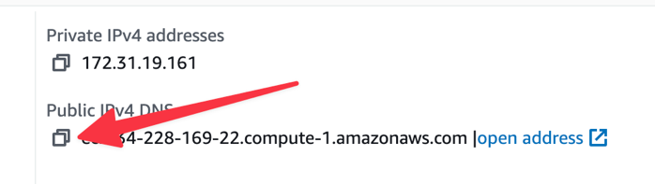
Note: You will want to save this, as you will need it in the upcoming steps.
- On Windows: Open PuTTY. If it is not installed on the computer that you are using, you can download the installer at https://www.chiark.greenend.org.uk/~sgtatham/putty/latest.html (Choose the MSI (“Windows Installer”) 64-bit x86 option). Do a “push through” install. If you used this method, skip to step 9.
On MacOS and Linux, you can connect directly through the terminal:
# ssh -l ec2-user -i ~/.ssh/Western-Student {server address from step 7}
The command breaks down as ssh, the program that we are using to connect, -l specifies the username you are connecting with (otherwise, it will use the username of the local computer), -i specifies the identity file (or keyfile) that you use to authenticate instead of a password. ~/.ssh/Western-Student is the path to the private key that you are using.
The first time you connect, you will get a security prompt. Type “yes” to save the host key. If you are using this method, skip to step 10.
- Configure your connection to your server with the following settings:
Setting | Value
Host Name (or IP address): | The value that you copied in step 7. (Should be something like ec2-XX-XX-XX-XX.compute-1.amazonaws.com)
Connection Category (left side) à Data: | Auto-login username: ec2-user
Connection à SSH à Auth à Credentials: | Private key file for authentication: Browse to the .ppk file that you downloaded in step 3, Key pair.
Window à Appearance | Under Font settings, click “Change” and set font to “Consolas” and size to 14.
Navigate back to Session: | Saved Sessions: DevOps Server  Click “Save.”  Click “Open.” The first time you connect, you will get a security prompt. Select “Accept” to save the host key.
- You should now be logged in as ec2-user to your AWS instance.
Note: If you cannot connect, it could be that your security group is not setup correctly. Contact your instructor if you think this may be the case.
Now that we are connected to your server, we want to be sure that it has the latest updates. Run the following command to update the system. Note: In a fresh Linux install not on AWS, we use the root account for all of our commands, so sudo (“superuser do,” or now “substitute user, do”) wasn’t needed. On AWS, we don’t login as root, so we must use sudo before any commands that require root.
# sudo dnf -y update
Your system should now be up to date and ready.
- Security Group Changes (Firewall)
To be able to use tools that we will be learning later in this course, we need to allow all traffic from the internet to our instance. To do this, navigate to the EC2 Dashboard in the top left of the screen:
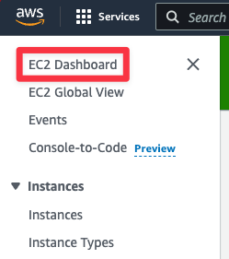
Select Security groups from the resources section at the top of the screen:
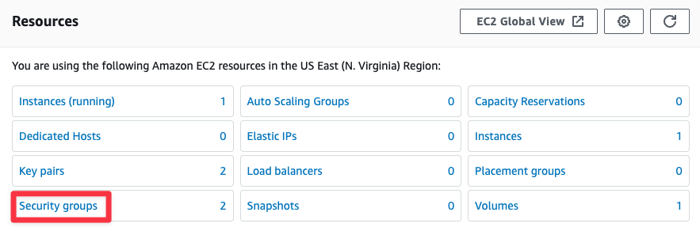
Select the security group ID that has the name “launch-wizard-1.”
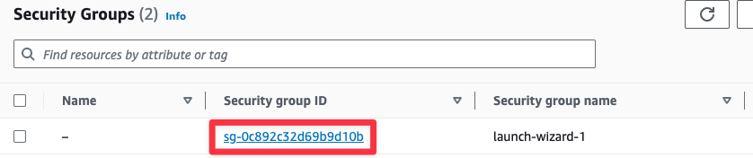
Under the Inbound rules section, click the Edit inbound rules button.
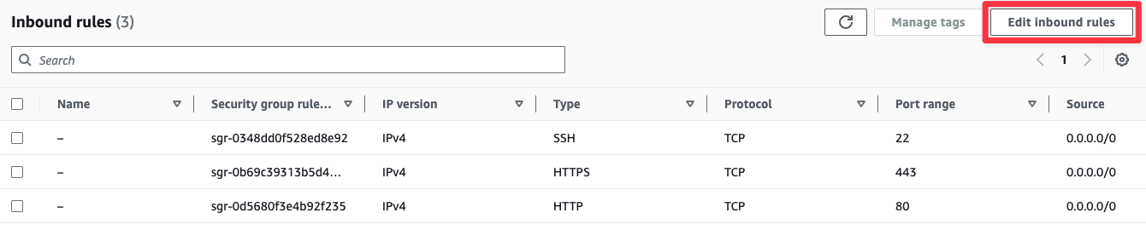
Click Add rule at the bottom.
Select All traffic from the Type dropdown list, and Anywhere IPv4 from the Source dropdown list.
Click Save rules.
- Server Information
For your server to be marked as complete, please provide the following information:
Server Address (Should be the address you got in step B.7: | ec2-174-129-47-191.compute-1.amazonaws.com
- Reflection
Reflect on the entire process of setting up a Linux server on an AWS instance. Consider the steps involved in configuring each component, the challenges you faced, and how you overcame them. How did this lab deepen your understanding of cloud services, and virtual machines? Discuss the importance of security measures, such as setting up billing alerts and securing your instance, in maintaining a production environment. Reflect on how this experience has prepared you for real-world cloud administration tasks and the potential impact of cloud computing on DevOps.
I found this lab to be a bit of a “blast from the past” moment, I was able to recognize the program that we used in the database admin class from fall of 2024. Though there was a lot less coding needed in putty to update the RedHat hardware. I am excited to utilize this system again in this course, and I am also excited to see a different application from this system. I am hoping that, like my last course, this quarter will even better prepare me for cloud computing in a real-world environment.

